**Discover Samsung Sale**

**BAR Plus USB 3.1 Flash Drive 256GB Titan Grey**

**MUF-256BE /MUF-256BE4/AM**

4.6 out of 5 stars, average rating value. Read 203 Reviews. Same page link.

4.6

(203)

Write a review

Share your product experience

* • • Transfer speeds up to 300MB/s.  
    
  • Backed by a 5-year limited warranty.

**Color**

[[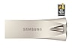](https://www.samsung.com/us/computing/memory-storage/usb-flash-drives/usb-3-1-flash-drive-bar-plus-256gb-champagne-silver-muf-256be3-am/)](https://www.samsung.com/us/computing/memory-storage/usb-flash-drives/usb-3-1-flash-drive-bar-plus-256gb-champagne-silver-muf-256be3-am/" \t "_self)

[[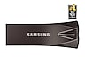](https://www.samsung.com/us/computing/memory-storage/usb-flash-drives/usb-3-1-flash-drive-bar-plus-256gb-titan-gray-muf-256be4-am/)](https://www.samsung.com/us/computing/memory-storage/usb-flash-drives/usb-3-1-flash-drive-bar-plus-256gb-titan-gray-muf-256be4-am/" \t "_self)

**Storage**

**[64GB](https://www.samsung.com/us/computing/memory-storage/usb-flash-drives/usb-3-1-flash-drive-bar-plus-64gb-titan-gray-muf-64be4-am/" \t "_self)**

[$13.99](https://www.samsung.com/us/computing/memory-storage/usb-flash-drives/usb-3-1-flash-drive-bar-plus-64gb-titan-gray-muf-64be4-am/" \t "_self)

**[128GB](https://www.samsung.com/us/computing/memory-storage/usb-flash-drives/usb-3-1-flash-drive-bar-plus-128gb-titan-gray-muf-128be4-am/" \t "_self)**

[$14.99 $20.99](https://www.samsung.com/us/computing/memory-storage/usb-flash-drives/usb-3-1-flash-drive-bar-plus-128gb-titan-gray-muf-128be4-am/" \t "_self)

**[256GB](https://www.samsung.com/us/computing/memory-storage/usb-flash-drives/usb-3-1-flash-drive-bar-plus-256gb-titan-gray-muf-256be4-am/" \t "_self)**

[$19.99 $34.99](https://www.samsung.com/us/computing/memory-storage/usb-flash-drives/usb-3-1-flash-drive-bar-plus-256gb-titan-gray-muf-256be4-am/" \t "_self)

**[512GB](https://www.samsung.com/us/computing/memory-storage/usb-flash-drives/bar-plus-usb-3-2-flash-drive-512gb-titan-gray-muf-512be4-am/" \t "_self)**

[$64.99](https://www.samsung.com/us/computing/memory-storage/usb-flash-drives/bar-plus-usb-3-2-flash-drive-512gb-titan-gray-muf-512be4-am/" \t "_self)



Get it by Dec. 24

**BAR Plus USB 3.1 Flash Drive 256GB Titan Grey$19.99**



**In-Store Pickup:**

-



**Delivery for:**

Total

**$19.99** $34.99

or **$**/mo

No Interest if Paid in full within **0** Month†

Interest is charged from the purchase date if the purchase amount is not paid in full within 6 Months. Standard APR 29.99%. Advertised payment is greater than required minimum payment.

You Saved Today**$15.00**



**Log in to earn up to 3 points per $1**

[**ADD TO CART**](javascript:;)

[**WHERE TO BUY**](https://www.samsung.com/us/computing/memory-storage/usb-flash-drives/where-to-buy/usb-3-1-flash-drive-bar-plus-256gb-titan-gray-muf-256be4-am/MUF-256BE4/AM)

Supported payment types:

Credit Card

**Buying online has never been easier or safer**

**Free Returns**

**Free returns for up to 15 days after your new monitor has been delivered to your home.**

[**LEARN MORE- Free Returns- Free Returns**](https://www.samsung.com/us/support/order-help/)

**Free shipping on most items**

**Order with confidence. Safe, contact-free two-day delivery.**

[**LEARN MORE- Free shipping on most items- Free shipping on most items**](https://www.samsung.com/us/support/order-faqs/#questionID20)

**Exclusive business savings**

**Enjoy exclusive volume discounts on eligible memory and storage, 0% Samsung Business Financing and limited time instant savings.**

[**LEARN MORE- Exclusive business savings- Exclusive business savings**](https://www.samsung.com/us/business/shop/all-deals/memory-storage-deals/)

**Speed in Style**

A modern take on a classic. The next generation Bar Plus elevates the flash drive to an everyday essential, offering impressive speeds in a striking design. Fits in your hand, a pure minimalism that cleverly blends style, speed, and reliability.

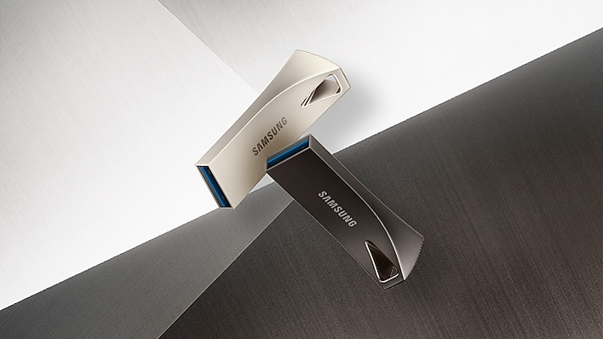

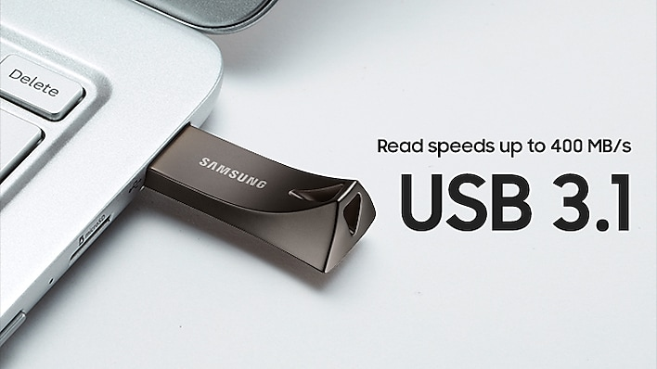

**Move Files in a Flash**

Get your time back. Fast and convenient read speeds up to 400MB/s¹ with the latest USB 3.1 standard gives you more time to work, play, watch, and create. Send a 3GB 4K UHD video file from your Bar Plus to your PC in just 10 seconds²

*¹Up to 400MB/s for 256/128GB models; Up to 300MB/s for 64GB model and up to 200MB/s for 32GB model.  
  
²Minimum of 10 secs for 256/128GB models; Minimum of 14 secs for 64/32GB models (tested with combination of Asus Z370-G, Intel i7-8700K@3.70GHz, 8GB DDR4 and Windows 10 Enterprise 64bit).*

**Rugged Refinement**

As rugged as it is stylish. The sturdy metal body keeps your data safe and intact, and the integrated key ring prevents accidental misplacement or loss. The Bar Plus is the ideal combination of stunning design and worry-free durability.

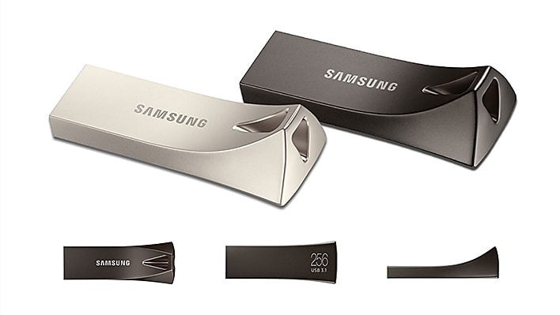

**Tough & Trusted**

Files stay secure, anywhere you go. Samsung's leadership in flash memory makes the Bar Plus a trustworthy drive to store your valuable data. It works through it all with a waterproof1, shock-proof2, temperature-proof3, magnet-proof4, and X-ray-proof5 body, all backed by a 5-year limited warranty6.

*1Up to 72 hrs in seawater.  
2Up to 1,500 gravitational acceleration.  
3Withstands -25°C to 85°C operating, -40°C to 85°C non-operating  
4Up to 15,000 gauss (equal to MRI).  
5Up to 50 Roentgen (equal to airport X-ray machines).  
6Samsung is not liable for any damages and/or loss of data or expenses incurred due to UFD data recovery. For specific details on warranty, please*